Newsletter – Friday 16th March 2018
Dear Parents/Carers,

We Love Books!
Our book week has been a great success. The purpose of the week has been to immerse the children in books and reading activities. The children have produced some excellent work based around their chosen text, through Art, Drama, Technology, Computing and Writing. Much of the work that has been done this week will be used as our entry to the ‘Bristol Book Project’, a competition that we won last year. The children have also been working very hard and creatively at home producing their entry to the school book competition. We have been very impressed with the quality of work and the effort that has been made by the pupils. The week’s events culminated today in a whole school celebration with children dressed as their favourite book characters and awards being presented in assembly. We hope very much that these events will help the children to love books and reading even more.
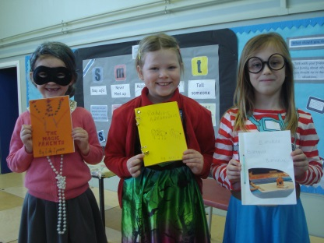
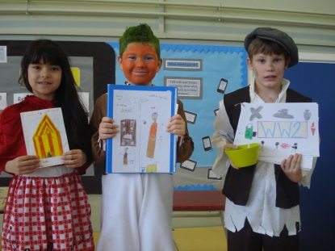
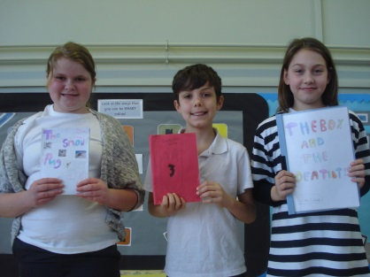

Sport Relief
Next week is ‘Sport Relief’ week. Throughout the week we will be ‘stepping up’ our physical activity by taking part in the Daily Mile. Children must have their PE kit in school every day. On Friday 23rd March, the children will be allowed to dress in their favourite sports clothes for the day and take part in a ‘Skipathon’ in exchange for bringing in a donation for ‘Sport Relief’. Money raised will be donated partly to sport relief and partly to the NSPCC, who came into school and delivered our internet safety workshops.

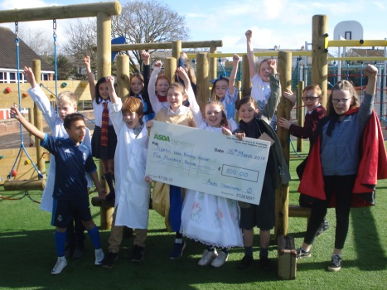
ASDA present a cheque to the school
Today in assembly, we were delighted to welcome Brenda Wright, school governor and ASDA community champion. Following our success in the ‘ASDA token challenge’ we received a cheque for the school for the sum of £500. These funds are vital to the school in helping us to provide the very best resources for our children.

Easter Disco
Great fun was had by all at the PTA Easter disco this week. A big thank you to the PTA for organising the event and to Nick for his DJ skills.

Year 3/ 4 Football Club
There will be no Year 3 / 4 football club next week Wednesday 21st March as I am on a training course that day.

Book Fair Date Change
Due to delays caused by school snow closures, the ‘Book Fair’ company are unable to visit on the dates we had planned. The ‘Book Fair’ will now be coming to school on the 25th April for one week. The Book Fair company that we use is offering books at discounted prices and they don’t accept ‘World Book Day’ book vouchers. Your ‘World Book Day’ vouchers can be exchanged in any book shop in part payment for a book or in exchange for the special ‘World Book Day’ £1 books.

Pinocchio Theatre Production
On Monday 19th March, M&M theatrical productions will be coming into school to perform Pinocchio. M&M have performed for the school on many occasions in the past and have always delivered first class performances. We very much hope that the children will enjoy the story and be inspired by the performers.

Little Musketeers Fencing Club
Little Musketeers Fencing Club started at Ashton Vale at the beginning of this term and we are delighted to say it has been a great success. The club will be continuing in terms 5 and 6. It is open to children from Year 1 to Year 6 and takes place after school on Wednesdays 3.15pm - 4.15pm. Your child will be bringing home a letter this week, giving all the details. If you would like to book a place, please fill in the reply slip with payment and return to the school office as soon as possible (places are limited).

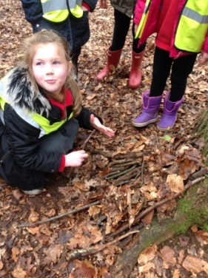
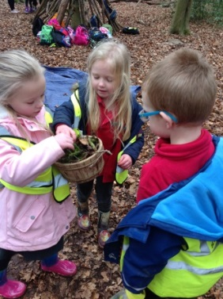
Year 1 trip to Leigh Woods
As part of their class topic called ‘Marvellous Materials’ Robin class have been reading a book called ‘Tidy’ by Emily Gravett. It is all about a very ‘tidy’ badger called Pete. He is a little too tidy and has to learn about all the creatures in the forest and what they need. Robin class have been to Leigh Woods to learn about forest creatures and build them homes. The children made hedgehog houses, nests for birds and learnt about special trees.

Easter Eggstravaganza
Ashton Vale Community Centre will be holding an Easter Eggstravaganza on Saturday 31st March, 10:30am - 1:30pm, £1 per child, adults free. There will be egg painting, biscuit decorating, an Easter bonnet competition, a scavenger hunt, cake sale, tea and coffee and much more. All welcome.

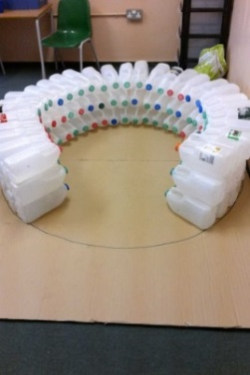
Community Clothing Collection for Kenya
Ashton Park School are collecting the following: baby, children, teenager and adult clothing, belts, handbags, clean quilt covers, blankets, warm hats, paired gloves and cloth bags. Donations can be brought to Ashton Vale from Monday 19th to Friday 23rd March. Items will be sorted and transported to the families of children at Inspirations School, Kenya.

Milk Bottle Appeal Year 1 Igloo
As part of their class topic called ‘Marvellous Materials’ Robin class have been asking important questions: how can I tell if something is man-made or natural? Why is it important to recycle? They are building an Igloo made out of 4Ltr plastic milk bottles (see picture right). They are running out of bottles and urgently need supplies in order to finish the Igloo and enter it as part of the ‘Bristol Book Project’. Thank you in advance for your help: please bring clean bottles into Year 1.

Dates:
Monday 19th March – Pinocchio Theatre Production
Week Beginning 19th March – Sport Relief
Friday 23rd March – End of Term Four
Monday 9th April - Term 5 begins
Wednesday 25th April - Book Fair arrives in school
Monday 14th May - Year 6 SATS week

Attendance
Attendance was slightly lower last week. Brilliant job Blue Jay and Flamingo class!
- YrR Penguin – 94.4 %
- Yr1 Robin – 93%
- Yr2 Flamingo – 96.7%
- Yr3 Crow – 88.3%
- Yr4 Falcon – 92.4%
- Yr5 Kingfisher – 94%
- Yr6 Blue Jay – 98.2%

Yours sincerely,

James Hollis,
Head Teacher

