Facebook link: https://m.facebook.com/phoneacqwrite/?s=1&source=m_mobile_mirror_interstitial

Newsletter No.15
Friday 6th January 2017

Dear Parent/Carers
Welcome back to the Spring Term at Ashton Vale, a diary of events is included with this newsletter.

Charity Collections
The children have raised £397.44 for The Poppy Appeal this year, thank you for your support.

The Christmas concert collection has now risen to £510.00 as the PTA have kindly donated the money raised at Carols Around The Tree.

Girls Football Club
Bristol City Community Trust have offered to run a girls football club here starting on Friday 13th January. This is open to all girls who are in Year 3, 4, 5 and 6. If your daughter would like to take part please complete the reply slip at the end of this letter and send them with suitable clothing including boots and shin pads next Friday.

Clubs
With this letter you will receive our new clubs choices. We are keen to start our clubs as soon as possible so please complete your child’s choices and return the form to us by next Tuesday 11th January. This means we can start clubs the week beginning 16th January.
Please note that Fun Outdoors club starts next week and will run for 6 weeks (the last session will be the first week of term 4).

Tobacco Factory Theatre Trip
Years 1, 2,3,4,5 and 6 are all off to see Cinderella next Wednesday 11th January. We have to arrive at the theatre by 12.45pm so the children will be eating an early lunch. Please could you provide a packed lunch on this day or if your child is eligible for Free School Meals or Universal Free School Meals and you would like our kitchen to prepare a packed lunch please can you let us know by Monday. Please note Reception will have lunch as normal.
The PTA have kindly funded half the cost of this trip so a voluntary contribution of just £3.50 per child is asked for via our on-line shop. Thank you.
The performance is due to finish at 3pm so we will be back at school by approximately 3.45pm. If you wish to collect your child from the Tobacco Factory please let your class teacher know by Wednesday morning, if you are late for any reason we will start walking back to school.

Year 5 Camp
Year 5 will be going to Mill On The Brue in four weeks’ time so excitement is rising. We are having a meeting for parents this Monday 9th January in Kingfisher Classroom at 3.15pm. Hopefully you received a text message earlier this week with this date.

PTA Recycling Collection
The collection has been postponed to Monday 30th January so please continue to collect up your recyclable textiles and we'll remind you nearer the time to bring them into school.

Headship Interviews
The interviews for the Headship vacancy have taken place this week so the governors will be able to let you know the outcome next week.

PTA Meeting
The PTA will be meeting on Thursday 12th January at 3.15pm in Penguin Class. Everyone is welcome so please come along if you are able to and would like to get involved in how the PTA raises and spends its funds.

Attendance
The expectation from Ofsted is that attendance for the school should be over 96%. At Ashton Vale we have not met this requirement and it does affect our behaviour for learning judgement. Please support us by booking holidays within the school holidays and by sending children to school with minor coughs/colds as we will take great care of them.
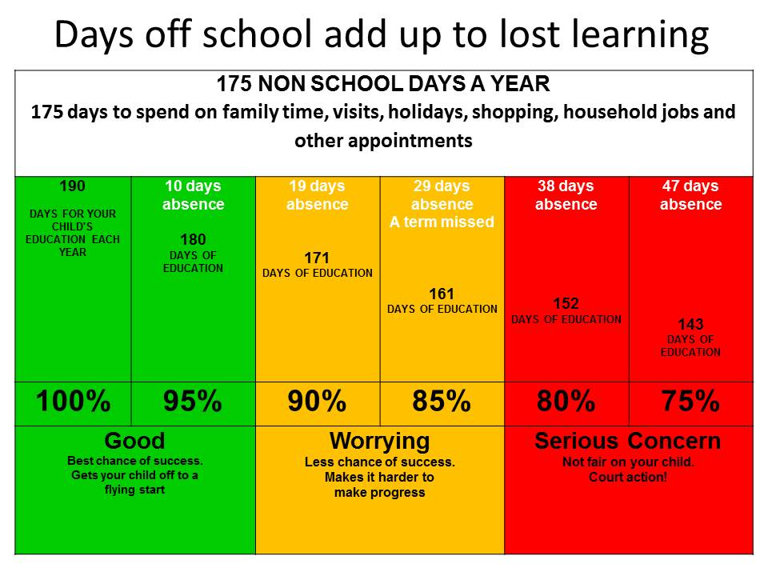

This week’s figures are:
Penguin 97.8% Robin 98.9% Flamingo 97.7% Crow 91.9%
Falcon 96.6% Kingfisher 97.2% Blue Jay 95.6%

Yours sincerely

Ms V Champeney
Headteacher

Girls Football Club

Name of pupil _________________________________ Class_________________

Will be joining the girls football club on Fridays this term.

Signed __________________________________________ Parent/Carer

