ASHTON VALE PRIMARY
Is part of Gatehouse Green Learning Trust: a company limited by guarantee.
Avebury Road, Ashton Vale, Bristol, BS3 2QG
Web Site: www.ashtonvaleprimary.weebly.com

Newsletter – Friday 8th March 2019
Dear Parents / Carers,

Science Week
Science week has gone with a real ‘Fizz, Pop, Bang!’ The children have had a variety of ‘Hands-On’ science experiences many of them involving spectacular chemical reactions. We hope these experiences have stimulated a curiosity in science and got the children thinking and wondering. Thank you to Mrs Hayes (parent and governor) for coming into school and sharing her expertise with Years 5 and 6: they had the opportunity to do a heart and lung dissection, which was both fascinating and amazing.

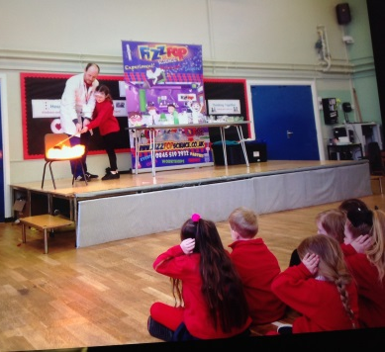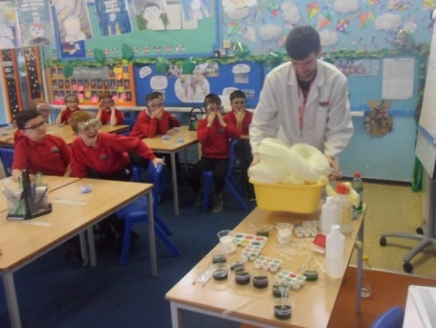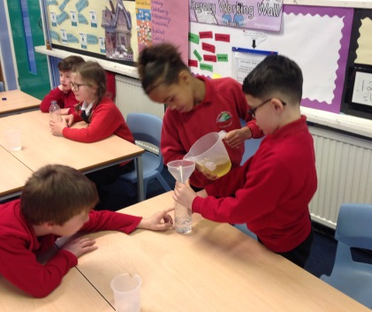

Year 5 Camp Assembly
The Year 5 children presented their camp assembly this morning. They delivered a very powerful message to us all about teamwork, friendship and rising to a challenge. It was great to see the comeradery that has been built up between the children during their camp adventure. It was aslo pleasing to see how the children have grown in confidence. Well done Year 5.

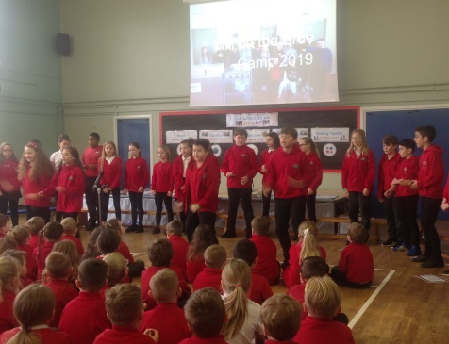
Intergenerational Project
A group of Year 5 and Year 6 children have been taking part in an intergenerational project linking with residents from Osborne Court Residential Care Home. Every month our pupils have been meeting with residents and doing art projects together. It is amazing to see the great ‘chemistry’ as the older and younger generations talk together and share their experiences. This has all been made possible by the charity ‘Alive’. Today the children and residents have attended a celebration party held by BBC Radio Bristol who have been sponsoring ‘Alive’ this year. The event was broadcast live on radio today and may be televised tonight on BBC Point West. Again, the children did us proud and behaved wonderfully.
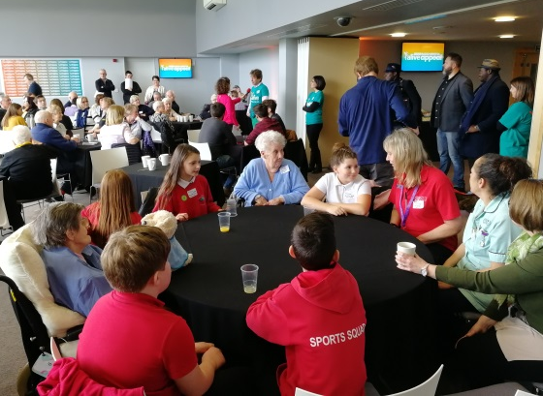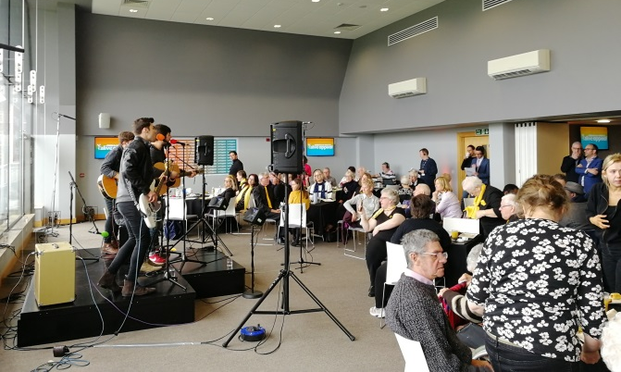

Red Nose Day Friday 15th March
Friday 15th of March is ‘Red Nose Day’. We will be supporting this very worthy fund raising event. The theme is ‘Wear something red and/or decorate your head!’ To participate in this event please bring in a donation for the ‘Red Nose Appeal’.

Litter Picking Year 4
On Thursday, the Year 4 class joined forces with the Ashton Vale Action Group and Bristol Waste to take part in a litter picking challenge on the streets around the school. The children did a very efficient job and in just one hour had collected a sack full of rubbish. It is important that our children have the opportunity to be involved in worthwhile work for the community.

Sports Events
Many of our children have had the opportunity to take part in sporting events recently. We have participated in a netball tournament, a gymnastics festival and both the boys and girls football teams have been in action. It is great that so many of our children are keen to participate. It is a chance for the children to develop their sporting skills, keep fit, compete and learn about teamwork and sportsmanship.

Reading Matters
Research shows that children who are ‘good readers’ by the age of 11 enjoy better health, live longer and have a higher sense of well-being.
Book Week
Book Week will be celebrated this year, week beginning 1st April. Our theme is ‘Share a Story’ which is the same as the World Book Day theme. Miss Green is working on some exciting new plans for ‘book week’, which will be linked with our Library Launch Day with Duncan Beedie on Tuesday 2nd April. This will include a special book themed event taking place after school in the library and infant playground, which everyone is invited to. Miss Green, the student council and PTA are busy organising this. The children have been reading the Duncan Beedie books in school this week and getting to know the characters. We hope that the children might get some inspiration for characters that they could dress up as on Tuesday 2nd April which is our book week dressing up day. On Friday 5th April we will be having an assembly (all welcome) to celebrate the work that the children have done in book week. The book competition will be changing: this year all children are going to work on writing a story in class, in school time and their work will be displayed in the hall during book week. Prizes will be awarded for best handwriting, illustrator and overall for each class.

Book Fair
On Friday 22nd March, the Book Fair will arrive in school and stay for a week. I know this has been very popular in the past and it is another opportunity to encourage our children to read for pleasure. A percentage of the sales comes back into school and is used to buy more books to add to our resources.

Old School Uniform
If you have any old school uniform that your child has grown out of, please hand it in to Mrs Fletcher in the school office. The PTA are then able to re-use/recycle.
Attendance League Table

Position | Class | Attendance
1 | Crow | 98%
2 | Flamingo | 95%
3 | Blue Jay | 94%
4 | Robin | 94%
5 | Falcon | 93%
6 | Penguin | 93%
7 | Kingfisher | 90%
 | Average | 94%

Dates:
Friday 15th March - Red Nose Day
Friday 22nd March - Book Fair Arrives for 1 week
Friday 29th March - Mothering Sunday Assembly Reception Class
Week beginning 1st April - Book Week
Tuesday 2nd April - Official Library Opening with Duncan Beedie
Tuesday 2nd April - Dressing Up Day Book Characters
Thursday 4th April - Year 2 Easter Assembly
Thursday 4th April - Year 4 Visit to SS Great Britain
Thursday 4th April - PTA Easter Disco
Friday 5th April - Book Week Celebration Assembly
Friday 5th April - Last Day of Term
Tuesday 24th April - Class photos 1pm

Yours sincerely,

James Hollis,
Head Teacher

