Key Stage 1 Book List
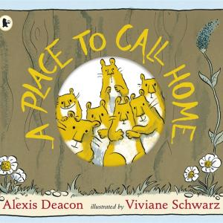
A Place To Call Home
By Alexis Deacon
Seven furry brothers emerge from the warm womblike home they have outgrown and travel in search of a new place in the wider world.

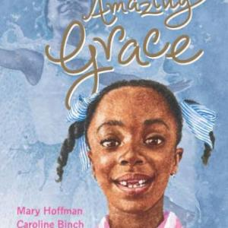
Amazing Grace
By Mary Hoffman
A wonderfully affirmative story. Grace ‘a girl who loved stories’ is told that she cannot play Peter Pan in the school pantomime because she is black and female.
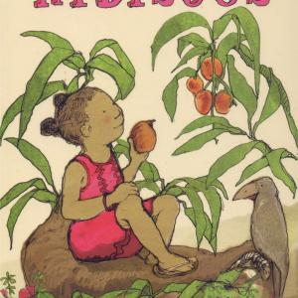
Anna Hibiscus
By Atinuke
Stories about the life of a small girl who lives in Africa with her African dad and Canadian mum and a large extended family.

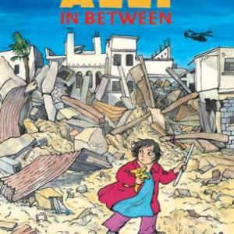
Azzi in Between
By Sarah Garland
Sarah Garland uses a comic strip format to tell the story of Azzi who has to flee her own country with her parents, leaving her grandmother behind, and settle as a refugee in a new country.
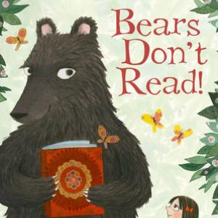
Bears Don't Read
By Emma Chichester Clark
Bears don’t read but George is a bear who desperately desires to do so. Finding a book beneath a tree in the forest, he heads for the town, determined to find someone who will teach him.

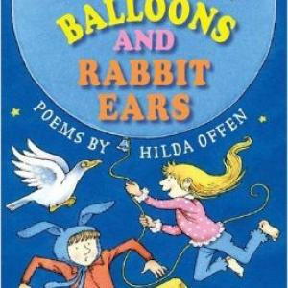
Blue Balloons and Rabbit Ears
By Hilda Offen
Download the FREE teaching sequence here
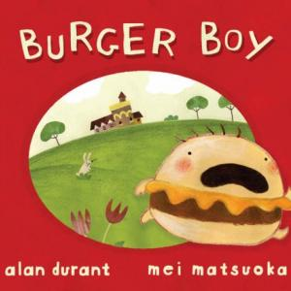
Burger Boy
By Alan Durant
Benny hates vegetables and loves burgers. So much so, that his mum tells him he will turn into a burger and – lo and behold! – he does!

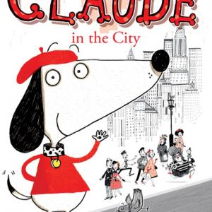
Claude in the City
By Alex T Smith
Claude is a small plump dog with a penchant for snazzy berets and a bent for problem solving. Accompanied by his sidekick Sir Bobblysock, he ventures into the city in the first of two episodes, followed by a second involving a visit to the hospital.
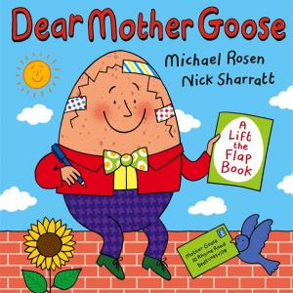
Dear Mother Goose
By Michael Rosen
Well known nursery rhyme characters write to Mother Goose with their problems and she suggests answers in agony aunt style.

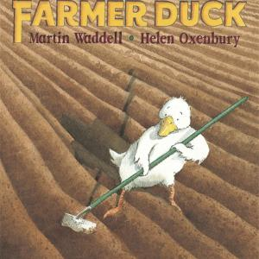
Farmer Duck
By Martin Waddell
It may not be commonly recognised by children that a duck is female; but unless this is appreciated the feminist message of this picture book will be lost.

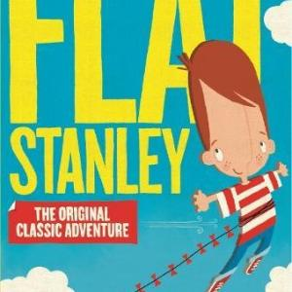
Flat Stanley
By Jeff Brown
At first it seems a disaster when Stanley Lambchop is flattened by an ‘enormous bulletin board’. However, he soon finds that his new proportions can be useful.

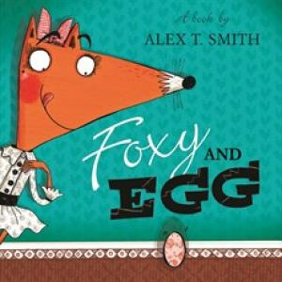
Foxy and Egg
By Alex T Smith
Egg rolls up at Foxy DuBois’ door and she anticipates a feast in store. First she tries to fatten him up but what finally hatches out of the egg is no chickenfeed!
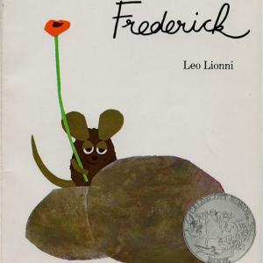
Frederick
By Leo Lionni
Frederick doesn’t join the other mice in storing up food for the winter. Instead he gathers the rays of the sun, colours and words, for he realises that he and his fellow creatures will not be sustained through the dark days by food alone.

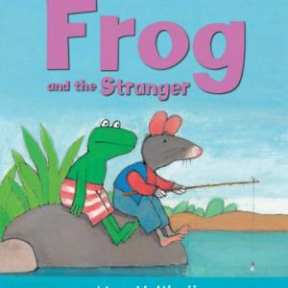
Frog and the Stranger
By Max Velthuijs
When Rat sets up home in their community, Frog is the only one prepared to get to know this ‘stranger’.
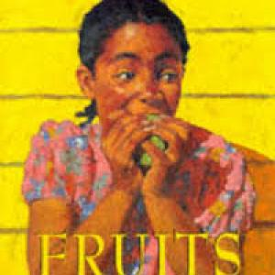
Fruits
By Valerie Bloom
A wryly amusing Caribbean counting poem enumerated in Jamaican Creole.

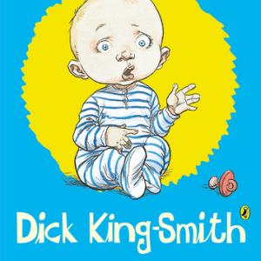
George Speaks
By Dick King-Smith
Some young children seem wise beyond their years, but none has ever been as advanced as this.
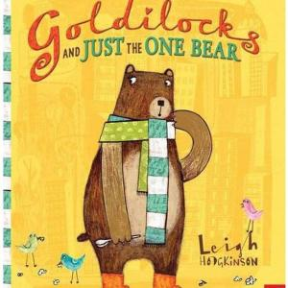
Goldilocks and Just the One Bear
By Leigh Hodgkinson
A solitary bear stumbles into the city and is as lost as a little girl might be in the woods. He enters a flat in a tower block where he finds food that’s just right.

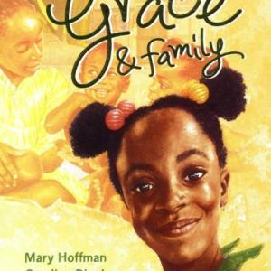
Grace & Family
By Mary Hoffman
In this sequel to Amazing Grace, Grace travels to the Gambia to visit her father and has to adjust to new relationships with his new wife and family.
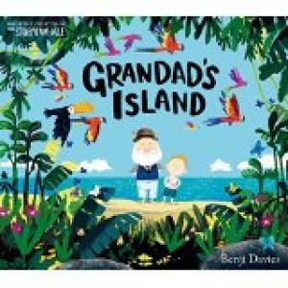
Grandad's Island
By Benji Davies
Syd has a very close relationship with his Grandad, whose house and garden back onto his own. On one of his regular visits, he finds Grandad in the attic.

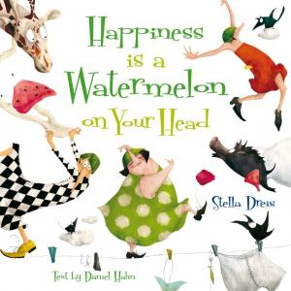
Happiness is a Watermelon on Your Head
By Daniel Hahn
Three very grumpy women are determined to find out why their neighbour Miss Jolly is always so happy. Is the secret in her bizarre headgear?

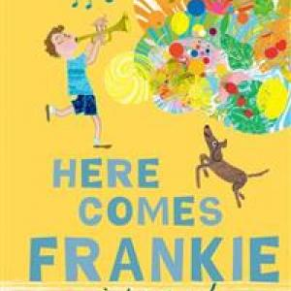
Here Comes Frankie
By Tim Hopgood
Frankie decides that the extremely quiet life he leads with his parents needs livening up and he acquires a trumpet.

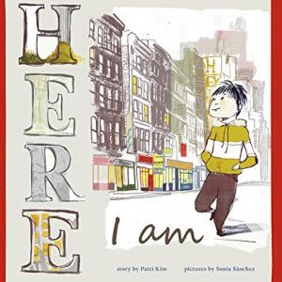
Here I Am
By Patti Kim
A young boy’s experience of the initial alienation and confusion is eloquently expressed in pictures placed on pages carefully designed in terms of layout and colour.
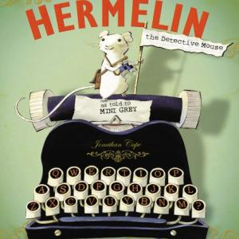
Hermelin
By Mini Grey
The opening spread of this picture book sets the scene for a tale of a mystery-solving mouse.

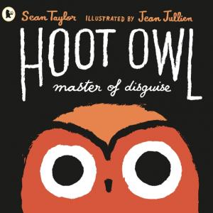
Hoot Owl, Master of Disguise
By Sean Taylor
Watch out! Hoot Owl is hungry in an offbeat story with deadpan humour and bold, striking illustrations. Hoot Owl is no ordinary owl. He is a master of disguise!
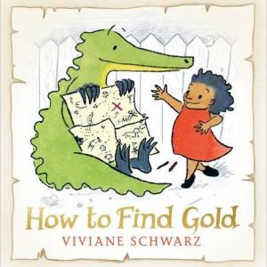
How to Find Gold
By Viviane Schwarz
In many ways the journey in pursuit of a goal and what you learn along the way is what makes it all worthwhile, much more than getting what you think you want.

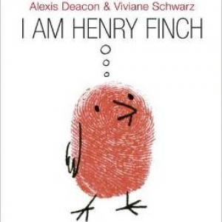
I Am Henry Finch
By Alexis Deacon
This story about the coming to consciousness of a small bird is the third collaboration between picture book creators Alexis Deacon and Viviane Schwarz, following A Place to Call Home and
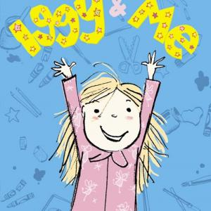
Iggy & Me
By Jenny Valentine
Flo relates episodes about family life with her sister Sam who renames herself Iggy in the first chapter.

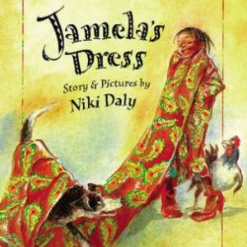
Jamela's Dress
By Niki Daly
Jamela so loves the beautiful material that her mother has bought to make a dress to attend a wedding that she wraps it around herself and parades around the South African township where she lives.
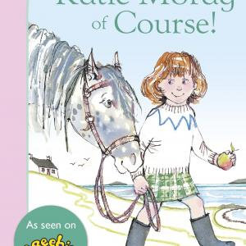
Katie Morag, Of Course!
By Mairi Hedderwick
A short chapter book containing three episodes in the lives of Katie Morag and her family and friends who live on the Scottish island of Struay.

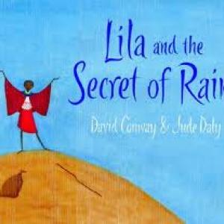
Lila and the Secret of Rain
By David Conway
There has been no rain in Lila’s Kenyan village for many weeks and “Without water there can be no life”, her mother says.

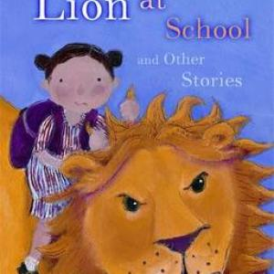
Lion at School and other stories
By Philippa Pearce
A rich mixture of tales for reading aloud or for confident new readers to read for themselves.

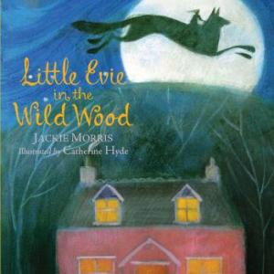
Little Evie in the Wild Wood
By Jackie Morris
A story with strong echoes of Red Riding Hood. Little Evie meets a wolf in the wood, a she wolf with ‘Great eyes, the better to see her with. Great ears, the better to hear her call.
Major Glad, Major Dizzy
By Jan Oke
An innovative book to share with children which will help them gain a conceptual understanding of history.

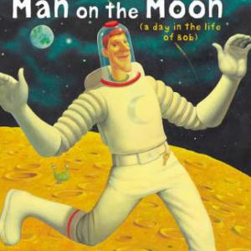
Man on the Moon (a day in the life of Bob)
By Simon Bartram
It’s Bob’s job to keep the Moon clean and tidy. He also welcomes tourist spaceships and gives guided tours.
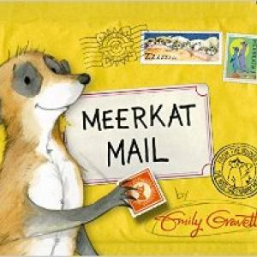
Meerkat Mail
By Emily Gravett
Sunny finds life with his typically close meerkat family somewhat claustrophobic and sets off to see the world.

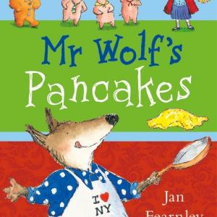
Mr Wolf's Pancakes
By Jan Fearnley
Hungry Mr Wolf fancies some pancakes. He tries to enlist the help of other fairytale characters such as Chicken Licken, the Gingerbread
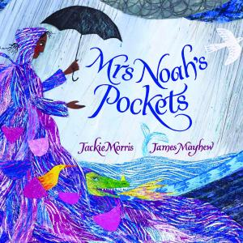
Mrs Noah's Pockets
By Jackie Morris
As the rain falls with increasing intensity and the water rises, Mr Noah makes a list of all the animals he believes should sail in the ark he is building.

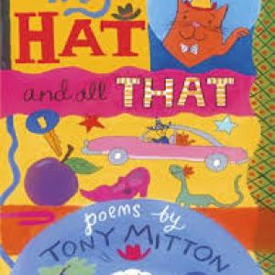
My Hat and All That
By Tony Mitton
A poetry collection for younger children, featuring everyday things written about in everyday language, used in inventive ways, and illustrated by humorous black and
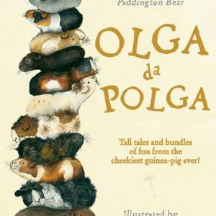
Olga da Polga
By Michael Bond
Life from a guinea pig’s viewpoint.

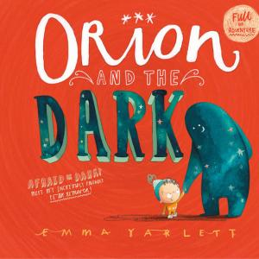
Orion and the Dark
By Emma Yarlett
Orion has a whole list of things he is scared of which are comically mapped out on the page. But the one thing that scares him more than anything else is ... the Dark! Then, one night, the Dark drops arrives in person for a visit and takes Orion on a journey.

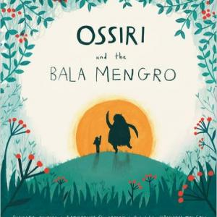
Ossiri and the Bala Mengro
By Richard O'Neill and Katharine Quarmby
Ossiri’s family is adept at recycling to support themselves. Her love of music leads her to fashion her own instrument using these skills and she creates what she calls a Tattin Django.

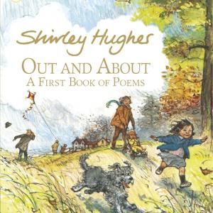
Out and About. A First Book of Poems
By Shirley Hughes
In this book of poetry the seasons are seen from a child’s eye view.
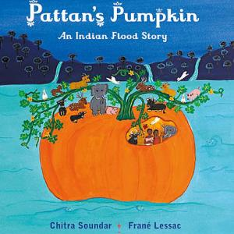
Pattan's Pumpkin
By Chitra Soundar
Storyteller Chitra Soundar has adapted this flood story from one told in Kerala in southern India. Pattan and his wife Kanni grow food which they share with all living creatures.

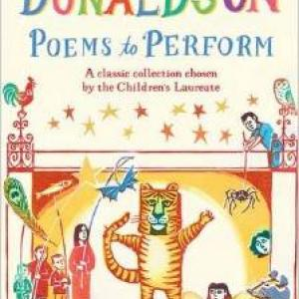
Poems to Perform
By Julia Donaldson
A careful selection of poems both familiar and new, edited by the former Children's Laureate, that lend themselves to being performed in a range of collaborative ways – by two voices, by grou
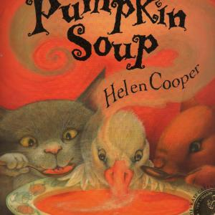
Pumpkin Soup
By Helen Cooper
A cat, a squirrel and a duck live together in an old white cabin deep in the woods. Each has his own job to do, including during the making of pumpkin soup.

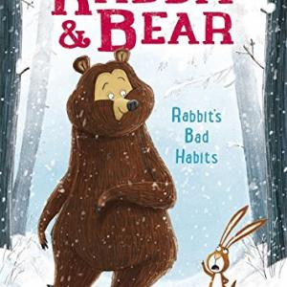
Rabbit & Bear: Rabbit's Bad Habits
By Julian Gough
Bear wakes up from her hibernation early to find snow on the ground and meets the grumpy and rather self-important although apparently very knowledgeable Rabbit.
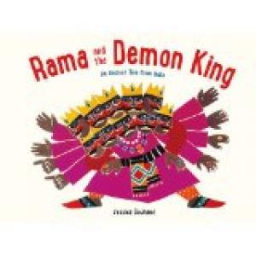
Rama and the Demon King
By Jessica Souhami
An eloquent retelling of the story, taken from the Indian epic the Ramayana, of how Prince Rama rescues his wife Sita and destroys Ravana, the ten-headed king of all the demons, with the help of Ha

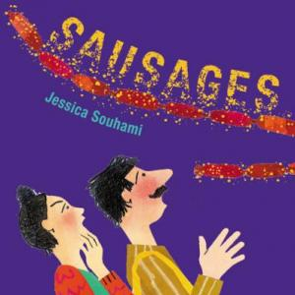
Sausages
By Jessica Souhami
A retelling of a folk tale about being careful what you wish for. John the woodcutter rescues an elf who grants him three wishes.
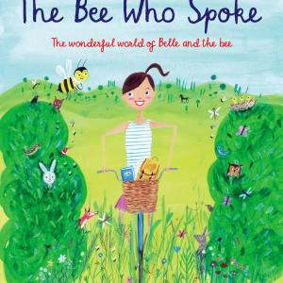
The Bee Who Spoke
By Al MacCuish
Parisian Belle holidays with her family in the countryside, which she explores on the bicycle that belonged to her mother when she was a girl.

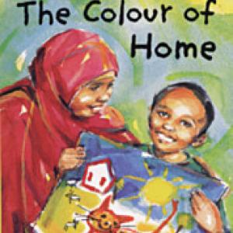
The Colour of Home
By Mary Hoffman
This picture book lets us into the world of Hassan, a young boy who has just arrived in Britain from Somalia.

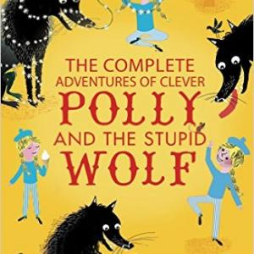
The Complete Adventures of Clever Polly and the Stupid Wolf
By Catherine Storr
Polly is visited over and over again by the Wolf, who is always plotting to eat her, but she is always just able to outwit him.

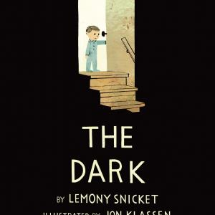
The Dark
By Lemony Snicket
Laszlo is afraid of the dark. The dark lives in the same house as Laszlo but mostly it spends its time in the basement. It doesn't visit Laszlo in his room. Until one night it does.
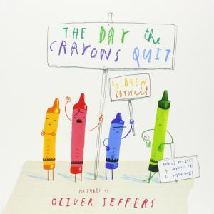
The Day the Crayons Quit
By Drew Daywalt
Duncan’s crayons desperately want to communicate with him so each of them writes him a letter.

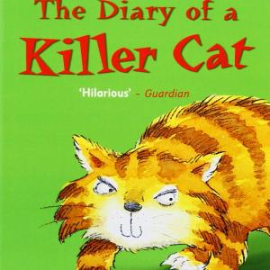
The Diary of a Killer Cat
By Anne Fine
A cat’s eye view of a week in which his family fail to appreciate the results of his hunting - and blame him for killing next door’s rabbit when all
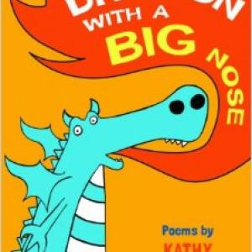
The Dragon with a Big Nose
By Kathy Henderson
These are odes to the urban environment - its buildings, its transport, the people and creatures that inhabit it and the effects of weather on it.

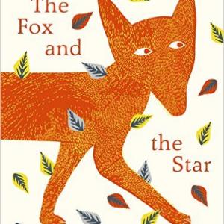
The Fox and the Star
By Coralie Bickford-Smith
A fox lives in a deep, dense forest depicted in stylised pictures which are strikingly and strongly patterned while evoking fresh sensations on every spread, using a predominantly blue, white and g
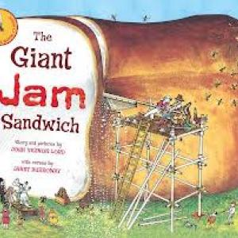
The Giant Jam Sandwich
By John Vernon Lord
The story, told in rhyming couplets, of how the resourceful villagers of Itching Down hatch an ingenious plan to rid their community of a plague of wasps.

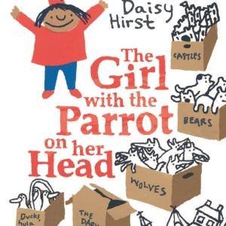
The Girl with the Parrot on her Head
By Daisy Hirst
A picture book about friendship and fears that demonstrates subtle psychological awareness. Left bereft when her friend moves away, Isabel organises her life in boxes.
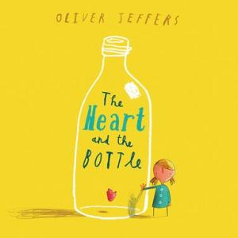
The Heart and the Bottle
By Oliver Jeffers
A curious child, saddened by loss, shuts away her heart in a bottle and seals off her wonderment at the world.

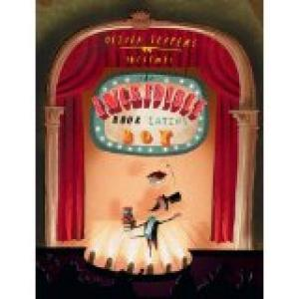
The Incredible Book Eating Boy
By Oliver Jeffers
Henry loves to consume books, quite literally.

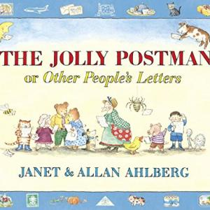
The Jolly Postman
By Janet & Allan Ahlberg
Sub-titled ‘Other People’s Letters’, this is a stupendous and original picture book. As the Postman delivers his letters to the Wicked Witch, the giant

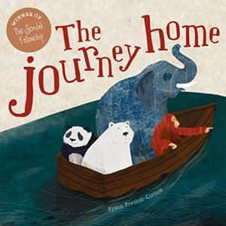
The Journey Home
By Fran Preston-Gannon
A polar bear realises that he needs to leave his Arctic home as the ice melts and his food supply dwindles. So he climbs into a little boat and sets sail.
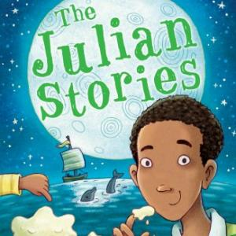
The Julian Stories
By Ann Cameron
Emotionally warm stories about an African-American family told in the first person by Julian, the elder of two young brothers.

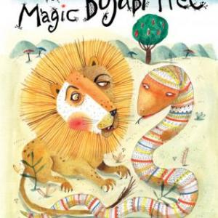
The Magic Bojabi Tree
By Dianne Hofmeyr
There is a drought on the plains of Africa and the animals are hungry. A tempting tree is covered in red, ripe fruit but
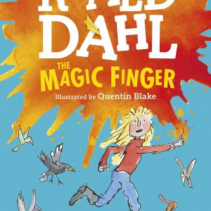
The Magic Finger
By Roald Dahl
The narrator of this tale is a young girl whose finger has magic powers which become active when she is angry.

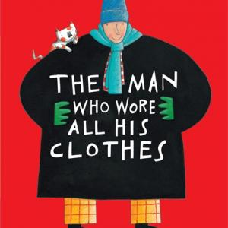
The Man Who Wore All His Clothes
In a book which crosses the divide between picture books and first chapter books, readers are introduced to the Gaskitt family.
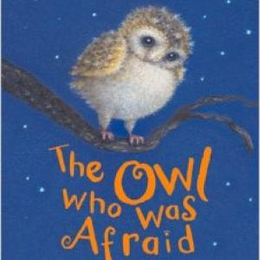
The Owl Who Was Afraid of the Dark
By Jill Tomlinson
A cunning story that will help children who are afraid of the dark to appreciate it and be unafraid.

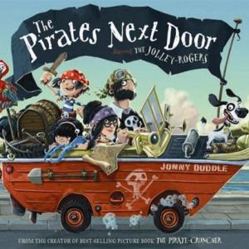
The Pirates Next Door
By Jonny Duddle
Matilda is delighted when her new neighbours turn out to be a pirate family, the Jolley-Rogers. The rest of the inhabitants of the dull seaside town where she lives are less than thrilled
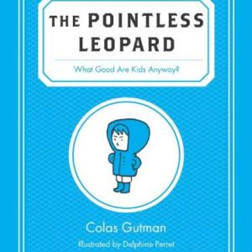
The Pointless Leopard
By Colas Gutman
All children love going to the countryside, don’t they? Not Leonard, whose parents assume he must appreciate its splendour.

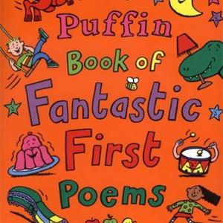
The Puffin Book of Fantastic First Poems
By June Crebbin
A lively collection of poems which are excellent to read aloud.

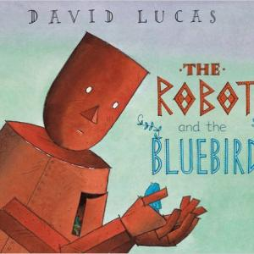
The Robot and the Bluebird
By David Lucas
A broken-hearted robot is left on the scrapheap. Day turns into night, Autumn into Winter, as he lies there, and this is beautifully and simply portrayed in four consecutive pictures.

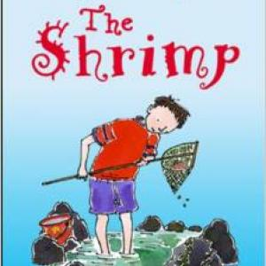
The Shrimp
By Emily Smith
When his new teacher asks her class to do a wildlife project over the summer holidays, Ben Shrimpton takes the opportunity to expand his knowledge of seashells
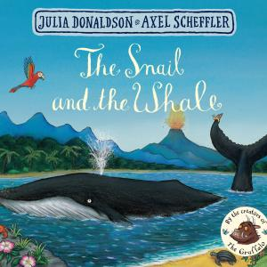
The Snail and the Whale
By Julia Donaldson
A tiny sea snail ‘with an itchy foot’ has a great desire to see the world and hitches a ride on the tail of a humpback whale.

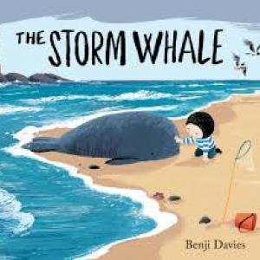
The Storm Whale
By Benji Davies
Noi lives a self-sufficient life with his dad by the sea in an isolated home reminiscent of the fishing huts at Hastings.
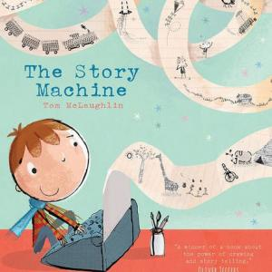
The Story Machine
By Tom McLaughlin
Elliott is a curious boy who finds a mysterious machine. He can’t figure out what to do with it.
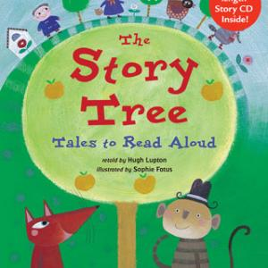
The Story Tree
By Hugh Lupton
The seven stories in this collection include familiar European tales as well as African, American, Indian and Jewish stories.
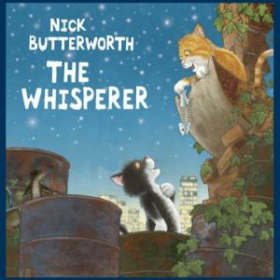
The Whisperer
By Nick Butterworth
A story in the tradition of Romeo and Juliet and West Side Story – Monty and Amber fall in love despite the fact that their families form rival gangs.

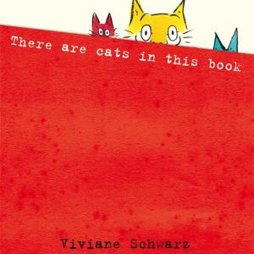
There Are Cats in This Book
By Viviane Schwarz
An inventive interactive book in which three playful cats directly address the readers, imploring them to keep turning the pages to make new discoveries, winding them in like a strand of a ball of
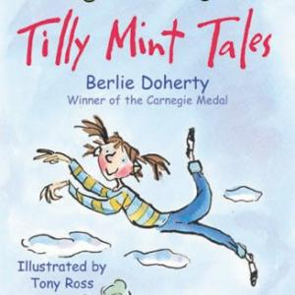
Tilly Mint Tales
By Berlie Doherty
Like a modern day Mary Poppins, whenever Mrs Hardcastle looks after Tilly Mint magical adventures always happen.

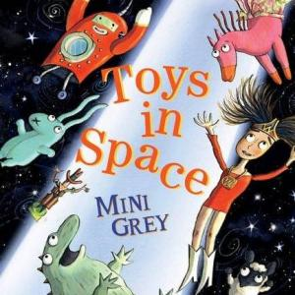
Toys in Space
By Mini Grey
Seven toys are left out in the garden one summer night and WonderDoll tells them a story to help the hours of darkness pass.

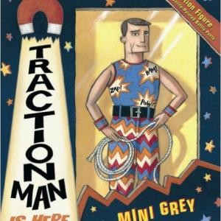
Traction Man is Here!
By Mini Grey
A boy receives an action figure as a Christmas present and the first half of this inventive picture book shows Traction Man’s exciting adventures

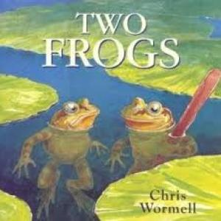
Two Frogs
By Chris Wormell
Two frogs sit on a lily pad in a blue and green watery environment that seems to stretch to infinity but is in fact a large pond.
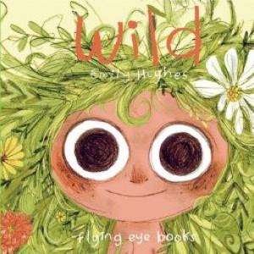
Wild
By Emily Hughes
Wild eyed with wonder, a small naked girl stares out from the cover of this picture book, the pupils of her eyes wide and luminous. Turn to the title page and the same child looks grim and cross, her hair trussed into a topknot, a hint of restrictive clothing below her chin.

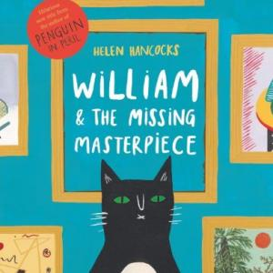
William & the Missing Masterpiece
By Helen Hancocks
William is a cat with an international reputation for solving mysteries. Disaster strikes when the famous painting, the Mona Cheesa, is stolen from a gallery
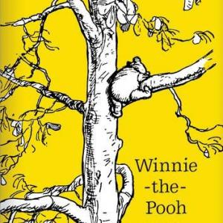
Winnie-the-Pooh
By A A Milne
A well-established classic which many children may have met only through Disney cartoons.

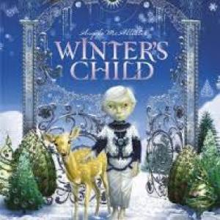
Winter's Child
By Angela McAllister
Tom wishes that winter would last forever. He inhabits a winter wonderland full of sparkling snowflakes and iridescent icicles
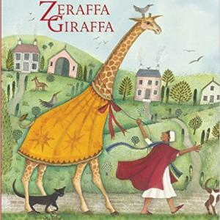
Zeraffa Giraffa
By Dianne Hofmeyr
A picture book inspired by the true story of a giraffe sent as a gift to the King of France by the Great Pasha of Egypt in the 1820s.

