Internet safety
What would you do if these scenarios happened to you?
- You are on a website when a page pops up saying you have won a prize and asks you to click on, what should you do?
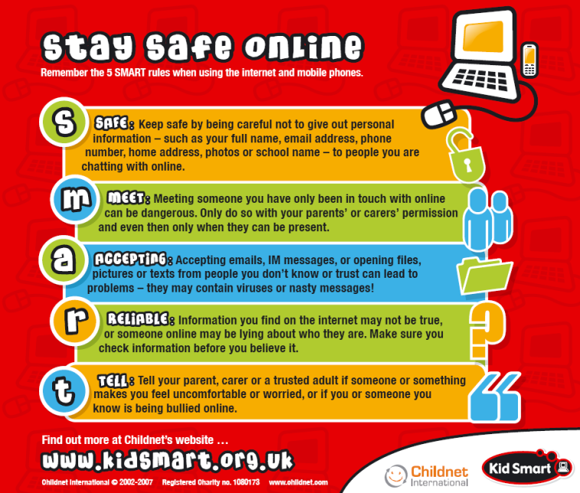
3.Someone from school sent you a nasty message online, what should you do?
2.Someone you don’t know very well has asked you for your mobile number, what should you do?
1.dont click on it, it could be a virus or something inappropriate or an internet stalker.
3.block those people they have no rights to bad mouth you, tell someone you trust e.g friends, teachers, parents immediately.
2.don’t give them your number because you should get to know them better first so if they are not who they seem and you delete them then they can’t re-contact you.
BEFORE YOU CLICK CLICK CLICK YOU’VE GOT TO THINK THINK THINK AND TELL SOMEBODY!!!!!!!!!

