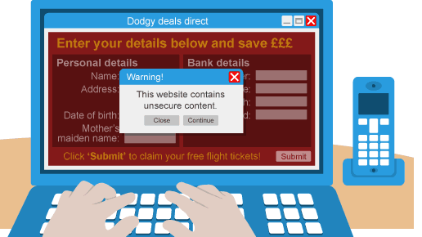
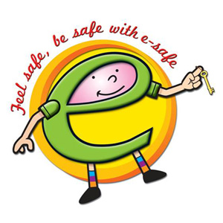
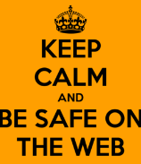
E – SAFETY
E-Safety Eddie
Don’t share personal Information online.

Your password is like
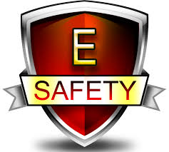
Your toothbrush you
Will never share any
Of them.

You should never share
any of your personal
information on any social websites.

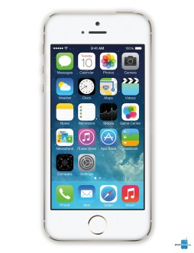
Remember, it’s not just computers you have to be safe on, it’s I pads and phones too.

AND REMEMBER FEEL SAFE, BE SAFE WITH E-SAFE!

