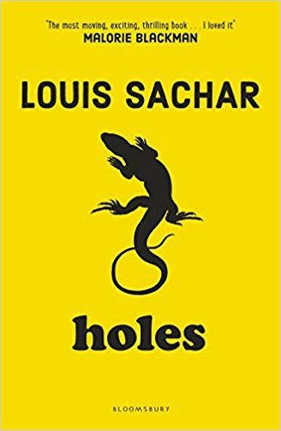

**PSHE**

**Celebrating difference-**

**Am I normal?**

**Understanding disability**

**Power struggles**

**Why Bully?**

**Celebrating difference**

**Maths**

Four operations on whole numbers – Multiplying, dividing, common multiples, common factors.

Fractions – Adding, Subtracting, Multiplying and Dividing.

**R.E**

Do Christmas celebrations and traditions help Christians understand who Jesus was and why he was born?

**Art and DT**

Yellow spotted lizards – Clay

Mini-book story maps with images.

**P.E**

* Real P.E
* Badminton

**Literacy**

**Book talk** – investigating our new book.

**Newspaper writing** – Writing an article based on an event in the book.

**Character descriptions** – Choosing favourite character and writing a biography.

**Topic**

**Crime and Punishment through the ages** – Romans, Saxons, Vikings, Medieval, Tudor and Victorians.

**CRIME AND PUNISHMENT**

**How has crime and punishment changed during history?**